Symbol / Word(s) | TM # | Trademark Description | Owner or Business
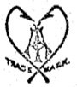 | 5207 | A & I | Abbey & Imbrie
 | 8374 | A & I | Abbey & Imbrie
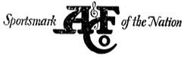 | 240424 | A&F | Abercrombie & Fitch Co. Inc.
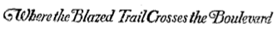 | 240425 | Company Motto (Blazed Trail) | Abercrombie & Fitch Co. Inc.
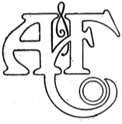 | 109960 | A&F | Abercrombie & Fitch Company
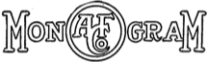 | 293683 | Monogram | Abercrombie & Fitch Company
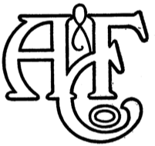 | 346982 | A&F | Abercrombie & Fitch Company
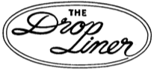 | 507093 | Drop Liner in Oval | Aircraft Specialties Company
 | 582974 | Ablette | Airex Corporation
 | 582975 | Preska | Airex Corporation
 | 583508 | Airex | Airex Corporation
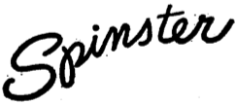 | 588719 | Spinster | Airex Corporation
 | 588720 | Vagabond | Airex Corporation
 | 602664 | Mastereel | Airex Corporation
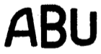 | 575634 | ABU | Aktiebolaget Urfabriken
 | 673147 | Abu-Matic | Aktiebolaget Urfabriken
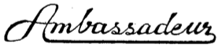 | 642051 | Ambassadeur | Aktiebotaget Urfabriken
 | 548449 | Aldenbilt | Aldens Inc
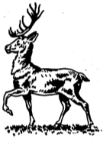 | 524999 | Stag | Allcock, S. & Co
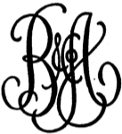 | 525745 | B & A Co. | Altman, B. & Co.
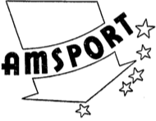 | 502016 | Amsport | AMCO Sports Distributors
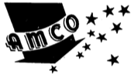 | 504968 | AMCO | AMCO Sports Distributors
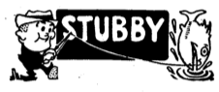 | 153958 | Stubby | American Display Company
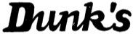 | 531972 | Dunk's | American Display Company
 | 365954 | Step Down | American Fork & Hoe Company
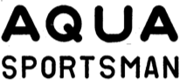 | 500150 | Aqua Sportsman | Aqua Sportsman, Inc
 | 644893 | Arjon | Arjon, Ab
 | 204540 | B / Infinity Symbol | Bakelite Corporation
 | 212509 | Bakelite | Bakelite Corporation
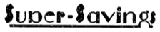 | 269393 | Super Savings | Bamberger, L. & Co
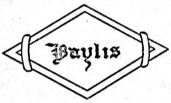 | 220235 | Baylis | Baylis Rod Company
 | 588956 | Blue Grass | Belknap Hardware and Mfg. Co
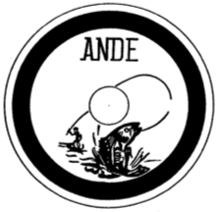 | 651147 | Ande | Berel, Arthur, Jr
 | 589053 | Trimline Jr. | Berger, Irving
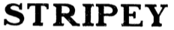 | 278067 | Stripey | Blaich, Adolph Incorporated
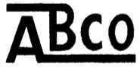 | 581608 | ABCO | Blaich, Adolph Incorporated
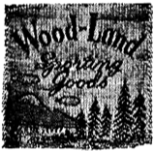 | 634222 | Wood Land | Bogardus, Ralph
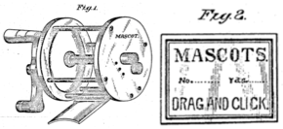 | 18004 | Mascot | Booth, Isaac J.
 | 595129 | Centaure | Booth, Richard P.
 | 435824 | Briggs | Briggs, George D.
 | 435825 | Duncan-Briggs | Briggs, George D.
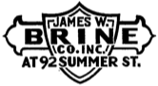 | 540923 | James W. Brine | Brine, James W. Co. Inc.
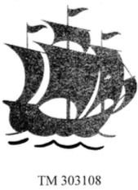 | 303108 | Sailing Ship | Bronson Reel Company
 | 307527 | Duo-Pawl | Bronson Reel Company
 | 506962 | Mercury | Bronson Reel Company
 | 513039 | Meteor | Bronson Reel Company
 | 513040 | Silver Princess | Bronson Reel Company
 | 513041 | Sparton | Bronson Reel Company
 | 513042 | Veteran | Bronson Reel Company
 | 513309 | Gladiator | Bronson Reel Company
 | 515052 | Fleetwing | Bronson Reel Company
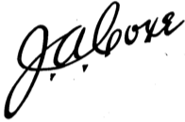 | 521429 | J.A. Coxe | Bronson Reel Company
 | 521436 | Altoona | Bronson Reel Company
 | 525624 | Lashless | Bronson Reel Company
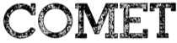 | 532658 | Comet | Bronson Reel Company
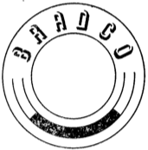 | 510281 | Bradco in Circle | Brown, Raymond E.
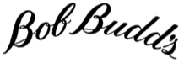 | 705928 | Bob Budd's | Budd, Robert A.
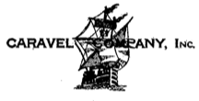 | 159834 | Caravel Company | Caravel Company
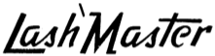 | 513258 | Lash/Master | Castmaster Fishing Reel Corporation
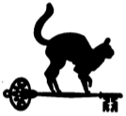 | 588642 | Cat & Key | Cat Cay Realty Company
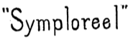 | 188153 | Symploreel | Catucci, Pliny
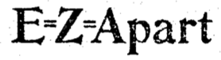 | 47837 | E=Z=Apart | Chamberlin Cartridge and Target Co
 | 354390 | Premax | Chisholm-Ryder Co
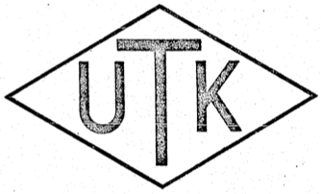 | 64894 | UTK | Clark-Horrocks Co
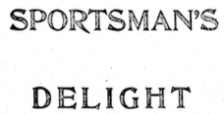 | 73255 | Sportsman's Delight | Clark-Horrocks Co
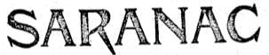 | 73256 | Saranac | Clark-Horrocks Co
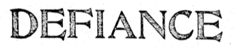 | 73257 | Defiance | Clark-Horrocks Co
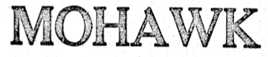 | 73637 | Mohawk | Clark-Horrocks Co
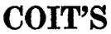 | 682484 | Coit's | Coit Ranch Incorporated
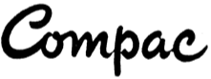 | 602315 | Compac | Commerce-Pacific Inc
 | 680366 | Continental | Commerce-Pacific Inc
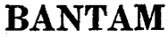 | 683203 | Bantam | Commerce-Pacific Inc
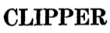 | 683614 | Clipper | Commerce-Pacific Inc
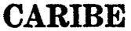 | 705921 | Caribe | Compagnie Francaise des Conduites d'Eau
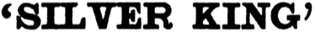 | 77298 | Silver King | Conroy, Thomas J.
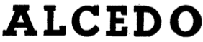 | 599011 | Alcedo | Continental Arms Corporation
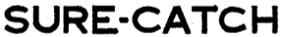 | 580394 | Sure-Catch | Cook, George F.
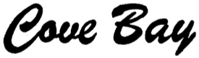 | 628179 | Cove Bay | Cove Bay Tackle Co
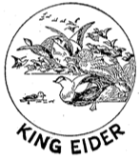 | 132924 | King Eider | Cumberland (Aylestone) LTD
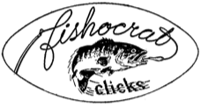 | 520231 | Fishocrat Clicks | Cummins, George A.
 | 519665 | Reliance | Cussins and Fearn Company
 | 508957 | Cycloid | Cycloid Corporation
 | 508958 | Micromatic | Cycloid Corporation
 | 523034 | Charles Daly | Daly, Charles, Inc
 | 652011 | Century | Denison-Johnson Corp.
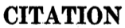 | 663085 | Citation | Denison-Johnson Inc
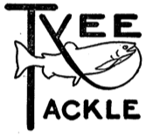 | 336621 | Tyee Tackle | Dunham, Carrigan & Hayden Co.
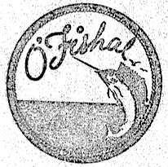 | 334989 | O'Fishal | Ederer, R. J. Net & Twine Co.
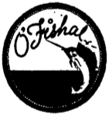 | 555290 | O'Fishal | Ellis, C. H. & Co
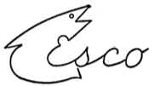 | 428452 | ESCO | Elsinger, Louis S.
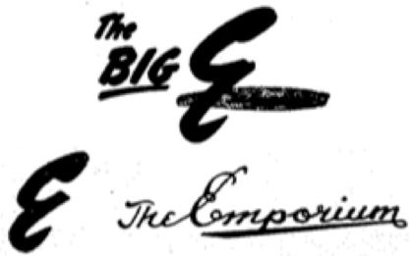 | 559780 | Big E | Emporium Capwell Company
 | 571290 | E in Circle | Emporium Capwell Company
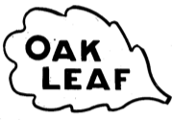 | 87183 | Oak Leaf | Enders, Wm. Manufacturing Company
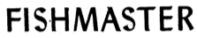 | 408647 | Fishmaster | Enholm, Lewis W.
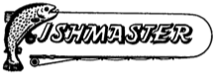 | 415817 | Fishmaster | Enholm, Lewis W.
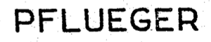 | 71940 | Pflueger | Enterprise Manufacturing Company
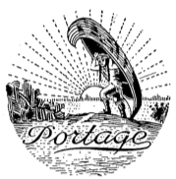 | 105722 | Portage & Canoe | Enterprise Manufacturing Company
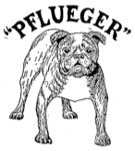 | 106419 | Pflueger & Bulldog | Enterprise Manufacturing Company
 | 106420 | Pelican | Enterprise Manufacturing Company
 | 123029 | Supreme | Enterprise Manufacturing Company
 | 123030 | Golden West | Enterprise Manufacturing Company
 | 123031 | Interocean | Enterprise Manufacturing Company
 | 154927 | Superex | Enterprise Manufacturing Company
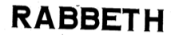 | 161937 | Rabbeth | Enterprise Manufacturing Company
 | 178771 | Williams | Enterprise Manufacturing Company
 | 178898 | Eureka | Enterprise Manufacturing Company
 | 178899 | Eclipse | Enterprise Manufacturing Company
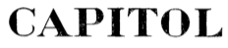 | 178900 | Capitol | Enterprise Manufacturing Company
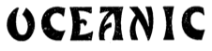 | 182364 | Oceanic | Enterprise Manufacturing Company
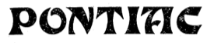 | 182365 | Pontiac | Enterprise Manufacturing Company
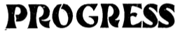 | 182366 | Progress | Enterprise Manufacturing Company
 | 182367 | Regal | Enterprise Manufacturing Company
 | 182368 | Rubber-City | Enterprise Manufacturing Company
 | 182369 | Seminole | Enterprise Manufacturing Company
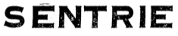 | 182370 | Sentrie | Enterprise Manufacturing Company
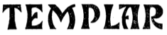 | 182372 | Templar | Enterprise Manufacturing Company
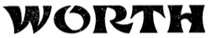 | 182373 | Worth | Enterprise Manufacturing Company
 | 182376 | Elinor | Enterprise Manufacturing Company
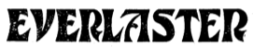 | 182377 | Everlaster | Enterprise Manufacturing Company
 | 195939 | Medina | Enterprise Manufacturing Company
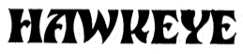 | 196215 | Hawkeye | Enterprise Manufacturing Company
 | 198199 | Wildwood | Enterprise Manufacturing Company
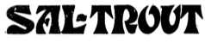 | 198200 | Sal-Trout | Enterprise Manufacturing Company
 | 198201 | Pastime | Enterprise Manufacturing Company
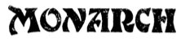 | 198204 | Monarch | Enterprise Manufacturing Company
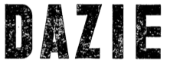 | 198206 | Dazie | Enterprise Manufacturing Company
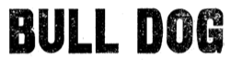 | 198764 | Bull Dog | Enterprise Manufacturing Company
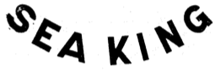 | 210875 | Sea King | Enterprise Manufacturing Company
 | 212397 | Gem | Enterprise Manufacturing Company
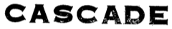 | 212399 | Cascade | Enterprise Manufacturing Company
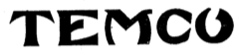 | 214579 | Temco | Enterprise Manufacturing Company
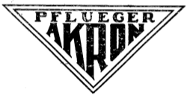 | 218324 | Akron | Enterprise Manufacturing Company
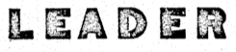 | 220006 | Leader | Enterprise Manufacturing Company
 | 224683 | Osage | Enterprise Manufacturing Company
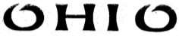 | 232803 | Ohio | Enterprise Manufacturing Company
 | 237686 | Taxie | Enterprise Manufacturing Company
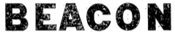 | 238801 | Beacon | Enterprise Manufacturing Company
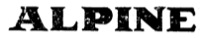 | 240196 | Alpine | Enterprise Manufacturing Company
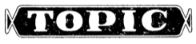 | 244085 | Topic | Enterprise Manufacturing Company
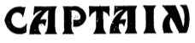 | 244086 | Captain | Enterprise Manufacturing Company
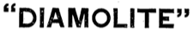 | 250007 | Diamolite | Enterprise Manufacturing Company
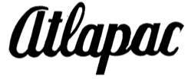 | 253340 | Altapac | Enterprise Manufacturing Company
 | 253342 | Sumco | Enterprise Manufacturing Company
 | 254601 | Egalite | Enterprise Manufacturing Company
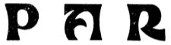 | 257492 | Par | Enterprise Manufacturing Company
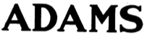 | 264298 | Adams | Enterprise Manufacturing Company
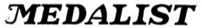 | 264904 | Medalist | Enterprise Manufacturing Company
 | 264947 | Bond | Enterprise Manufacturing Company
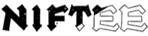 | 265377 | Niftee | Enterprise Manufacturing Company
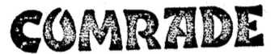 | 285597 | Comrade | Enterprise Manufacturing Company
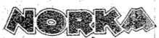 | 287175 | Norka | Enterprise Manufacturing Company
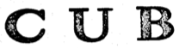 | 291374 | Cub | Enterprise Manufacturing Company
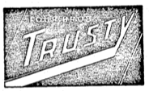 | 291714 | Trusty | Enterprise Manufacturing Company
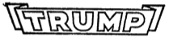 | 298593 | Trump | Enterprise Manufacturing Company
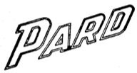 | 299877 | Pard | Enterprise Manufacturing Company
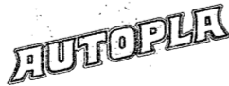 | 301751 | Autopla | Enterprise Manufacturing Company
 | 324481 | Nobby | Enterprise Manufacturing Company
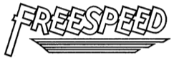 | 359884 | Freespeed | Enterprise Manufacturing Company
 | 379419 | Rocket | Enterprise Manufacturing Company
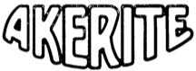 | 385613 | Akerite | Enterprise Manufacturing Company
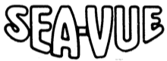 | 385614 | Sea-Vue | Enterprise Manufacturing Company
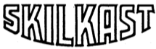 | 387426 | Skilkast | Enterprise Manufacturing Company
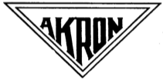 | 511801 | Akron | Enterprise Manufacturing Company
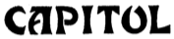 | 511803 | Capitol | Enterprise Manufacturing Company
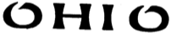 | 511853 | Ohio | Enterprise Manufacturing Company
 | 513720 | Williams | Enterprise Manufacturing Company
 | 521593 | Alpine | Enterprise Manufacturing Company
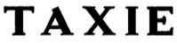 | 521594 | Taxie | Enterprise Manufacturing Company
 | 585338 | Oceanic | Enterprise Manufacturing Company
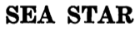 | 633955 | Sea Star | Enterprise Manufacturing Company
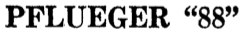 | 663746 | Pflueger "88" | Enterprise Manufacturing Company
 | 678375 | Pflueger Mars | Enterprise Manufacturing Company
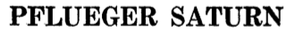 | 697077 | Pflueger Saturn | Enterprise Manufacturing Company
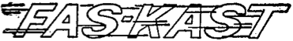 | 704923 | Fas-Kast | Enterprise Manufacturing Company
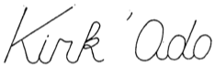 | 706927 | Kirk 'Ado | Fabrique d'Horlogeric Odo
 | 661886 | Nemrod | Ferrando, Juan Y Pedro Villarrubis
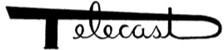 | 616135 | Telecast | Fihe, Albert J.
 | 519063 | Firefly | Firelure Corporation
 | 554196 | Firelure | Firelure Corporation
 | 554407 | Fire | Firelure Corporation
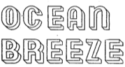 | 397178 | Ocean Breeze | Firestone Tire & Rubber Company
 | 440450 | Fishcrafters | Fishcrafters
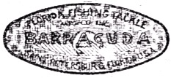 | 310314 | Barracuda | Florida Fishing Tackle Mfg. Co., Inc.
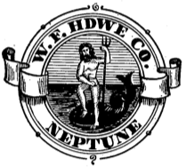 | 106592 | Neptune | Frankfurth, Wm. Hardware Co
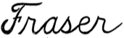 | 502591 | Fraser | Fraser Reel and Specialty Company
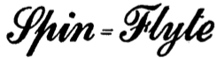 | 566062 | Spin-Flyte | French Industries, Inc
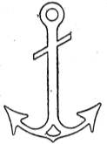 | 130500 | Anchor | From, Harris
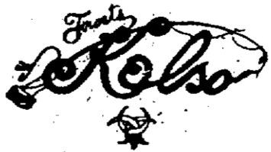 | 95536 | Frost's Kelso | Frost, H. J. & Company
 | 535703 | Hiawatha | Gamble-Skogmo Inc
 | 696716 | Garcia | Garcia Corporation
 | 562465 | Mitchell Spinning Reel | Garcia, Charles & Co, Inc
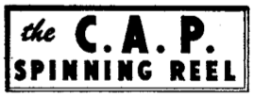 | 576963 | C.A.P. Spinning Reel | Garcia, Charles & Co, Inc
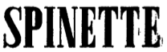 | 585337 | Spinette | Garcia, Charles & Co, Inc
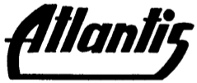 | 595871 | Atlantic | Garcia, Charles & Co, Inc
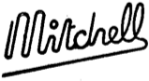 | 629434 | Mitchell | Garcia, Charles & Co, Inc
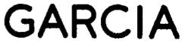 | 631973 | Garcia | Garcia, Charles & Co, Inc
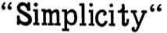 | 429222 | Simplicity | Gayle, Geo W. & Son
 | 255682 | Pop Geer | Geer, Ralph C.
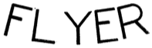 | 233618 | Flyer | General Industries Company
 | 238981 | GIM | General Industries Company
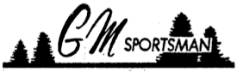 | 695582 | GM Sportsman | General Merchandise Co
 | 153374 | Meisselbach | General Phonograph Corporation
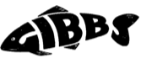 | 509093 | Gibbs | Gibbs, Rufus C.
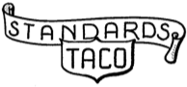 | 427063 | Standards TACO | Ginsburgh, Harry D.
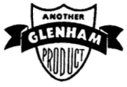 | 689817 | Glenham | Glenham Products Co
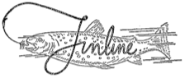 | 353944 | Finline | Gorsline Finch Sporting Goods Company
 | 577102 | Goof's | Graham, Edward L.
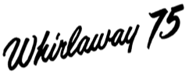 | 615655 | Whirlaway 75 | Great Lakes Products Inc
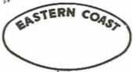 | 330614 | Eastern Coast | H & D Folsom Arms Company
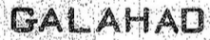 | 151157 | Galahad | Hadfields, LTD
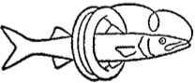 | 557150 | Fish in Spool | Handicast Company
 | 560287 | Handicast | Handicast Company
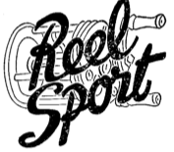 | 527666 | Reel Sport | Harris & Gordon
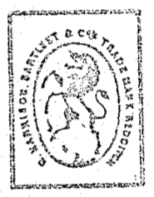 | 10189 | Unicorn | Harrison, R., Bartleet & Co
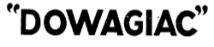 | 175713 | Dowagiac | Heddon's, James Sons
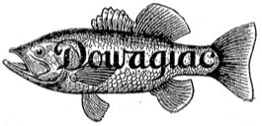 | 184539 | Dowagiac | Heddon's, James Sons
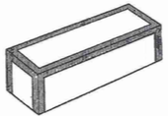 | 345384 | Lure Box | Heddon's, James Sons
 | 504151 | Heddon-Dowagiac | Heddon's, James Sons
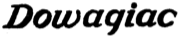 | 504153 | Dowagiac | Heddon's, James Sons
 | 507483 | Heddon-Made is Well-Made | Heddon's, James Sons
 | 507613 | Heddon | Heddon's, James Sons
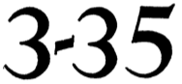 | 513274 | 3-35 | Heddon's, James Sons
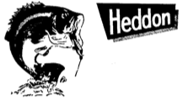 | 531996 | Heddon & Leaping Bass | Heddon's, James Sons
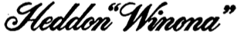 | 581012 | Heddon Winona | Heddon's, James Sons
 | 586127 | Pal | Heddon's, James Sons
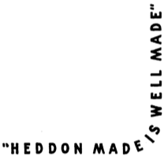 | 615293 | Heddon Made Is Well Made | Heddon's, James Sons
 | 370381 | Hedge | Hedge, Marvin K.
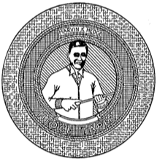 | 372379 | Man (Mr. Hedge) | Hedge, Marvin K.
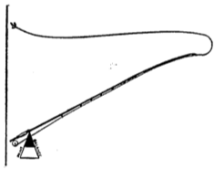 | 420930 | Point of Balance | Hedge, Marvin K.
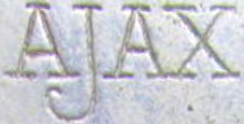  Image from Reel Talk posted by TEAL | 29655 | Ajax | Hibbard, Spencer, Bartlett & Company
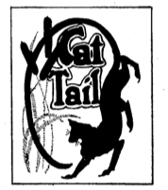 | 135260 | Cat Tail | Hibbard, Spencer, Bartlett & Company
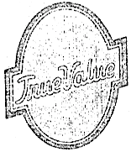 | 334196 | True Value | Hibbard, Spencer, Bartlett & Company
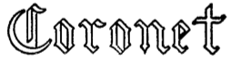 | 576460 | Coronet | Higbie Manufacturing Company
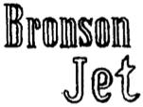 | 618990 | Bronson Jet | Higbie Manufacturing Company
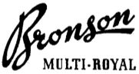 | 626487 | Bronson Multi Royal | Higbie Manufacturing Company
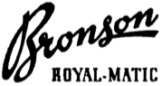 | 626488 | Bronson Royal-Matic | Higbie Manufacturing Company
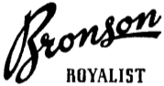 | 626489 | Bronson Royalist | Higbie Manufacturing Company
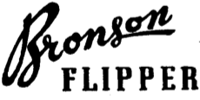 | 633094 | Bronson Flipper | Higbie Manufacturing Company
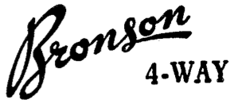 | 635851 | Bronson 4-Way | Higbie Manufacturing Company
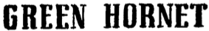 | 636141 | Green Hornet | Higbie Manufacturing Company
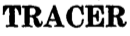 | 643214 | Tracer | Higbie Manufacturing Company
 | 643215 | Torrent | Higbie Manufacturing Company
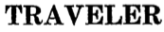 | 643216 | Traveler | Higbie Manufacturing Company
 | 669553 | Bronson Spin King | Higbie Manufacturing Company
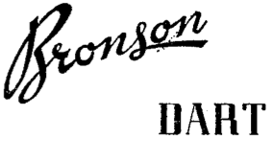 | 707165 | Bronson Dart | Higbie Manufacturing Company
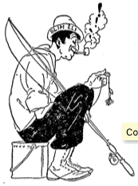 | 236796 | Fisherman on Bucket | Hildebrandt, John J. Company
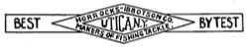 | 174991 | Best By Test | Horrocks-Ibbotson Co
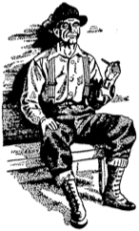 | 438913 | Man Sitting | Horrocks-Ibbotson Company
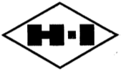 | 441483 | H-I | Horrocks-Ibbotson Company
 | 441705 | Old Hi's Favorite | Horrocks-Ibbotson Company
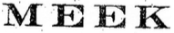 | 117560 | Meek | Horton Manufacturing Co
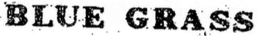 | 117561 | Bluegrass | Horton Manufacturing Co
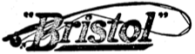 | 300441 | Bristol | Horton Manufacturing Company
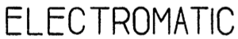 | 508537 | Electromatic | Horton Manufacturing Company
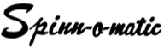 | 634339 | Spinn-o-matic | Humpal Manufacturing Co
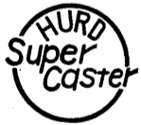 | 549735 | Hurd Super Caster | Hurd Lock & Manufacturing Company
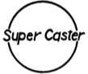 | 549751 | Super Caster | Hurd Lock & Manufacturing Company
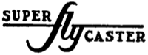 | 552085 | Super Fly Caster | Hurd Lock & Manufacturing Company
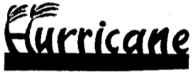 | 582061 | Hurricane | Hurricane Manufacturing Company
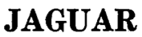 | 656373 | Jaguar | Irving's
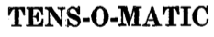 | 701728 | Tens-O-Matic | Jamco Industries, Inc.
 | 697078 | Uneek | Jones, Ulric C.
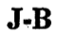 | 657399 | J-B | Jorgensen Bros.
 | 658019 | Imperial | Jorgensen Bros.
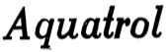 | 523218 | Aquatrol | KDF Products, Inc
 | 83584 | Hickory | Kelley-How-Thomson Co
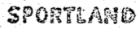 | 334315 | Sportland | Kelley-How-Thomson Co.
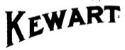 | 90447 | Kewart | Kewell, Charles H.
 | 520956 | Fix-Reel | Kneubuhler, Hans
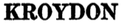 | 707757 | Kroydon | Kroydon Company, Inc.
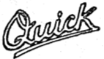 | 603555 | Quick | Kuntze, Hellmuth
 | 431290 | Streamlite | Langley Corporation
 | 443705 | Lurecast | Langley Corporation
 | 500029 | Target | Langley Corporation
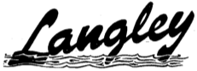 | 505903 | Langley | Langley Corporation
 | 513923 | Anti-Inertia | Langley Corporation
 | 522946 | Lakecast | Langley Corporation
 | 523265 | Plugcast | Langley Corporation
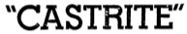 | 523270 | Castrite | Langley Corporation
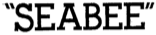 | 535215 | Seabee | Langley Corporation
 | 597295 | Spinflo | Langley Corporation
 | 611379 | Spinator | Langley Corporation
 | 615279 | Spinlite | Langley Corporation
 | 631677 | Spin Drift | Langley Corporation
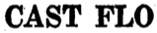 | 658255 | Cast Flo | Langley Corporation
 | 418169 | Laurentian | Lawson, Holger
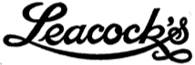 | 426480 | Leacock's | Leacock Sporting Goods Company, Inc.
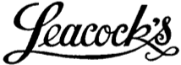 | 513127 | Leacock's | Leacock Sporting Goods Company, Inc.
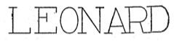 | 167070 | Leonard | Leonard, H. L. Rod Co
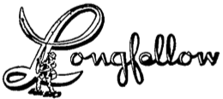 | 705188 | Longfellow | Longfellow Products, Inc
 | 622991 | Netcraft | Ludgate, Herbert T.
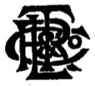 | 123733 | Company Monogram | Ludgate, Ryder, Thomas & Co
 | 372651 | L & C | Lyon & Coulson, Inc.
 | 607898 | MEPPS | M.E.P.P.S. Manufacture
 | 377251 | Morrison | Madison-Kipp Corporation
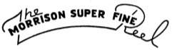 | 377252 | Morrison Super Fine Reel | Madison-Kipp Corporation
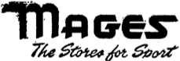 | 561764 | Mages | Mages Sports Stores, Inc
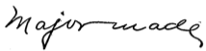 | 273490 | Major Made | Major, Harlan W.
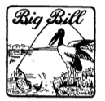 | 136530 | Big Bill | Marshall-Wells Company
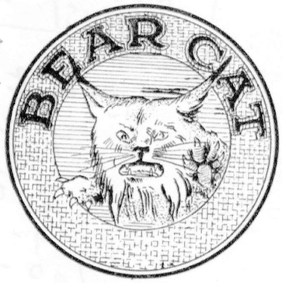 | 148451 | Bear Cat | Marshall-Wells Company
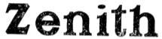 | 182352 | Zenith | Marshall-Wells Company
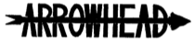 | 201295 | Arrowhead | Marshall-Wells Company
 | 374300 | Packard | Marshall-Wells Company
 | 584232 | Packard | Marshall-Wells Company
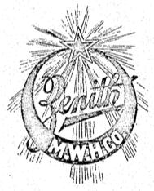 | 71390 | Zenith | Marshall-Wells Hardware Co
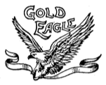 | 88684 | Gold Eagle | Martin's, E. J. Sons
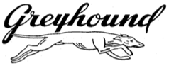 | 382515 | Greyhound | May Department Stores
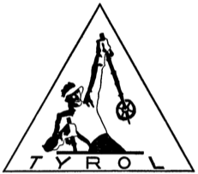 | 371828 | Tyrol | Mayer, Franz
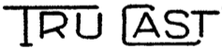 | 357863 | Tru Cast | Maynes, Hyla F.
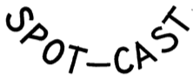 | 359450 | Spot-Cast | Maynes, Hyla F.
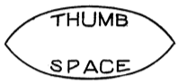 | 360174 | Thumb Space | Maynes, Hyla F.
 | 372041 | Spiral Wind | Maynes, Hyla F.
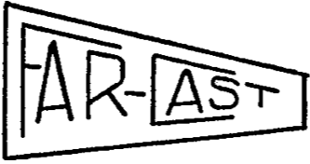 | 372707 | Far-Cast | Maynes, Hyla F.
 | 372708 | Free Cast | Maynes, Hyla F.
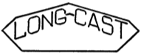 | 372709 | Long-Cast | Maynes, Hyla F.
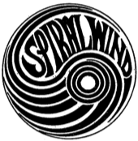 | 374063 | Spiral Wind | Maynes, Hyla F.
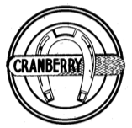 | 87229 | Cranberry | McClung, C. M. & Co
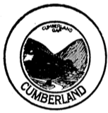 | 88508 | Cumberland | McClung, C. M. & Co
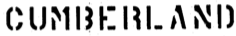 | 518991 | Cumberland | McClung, C. M. & Co
 | 87228 | Cherokee | McClung, C.M. & Co
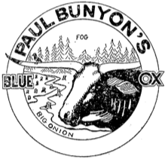 | 199148 | Paul Bunyon's | Means, Norman E.L.
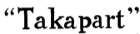 | 153602 | Takapart | Meisselbach, A. F. Manufacturing Company
 | 153603 | Fishing Reel of Quality | Meisselbach, A. F. Manufacturing Company
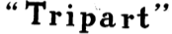 | 153605 | Tripart | Meisselbach, A. F. Manufacturing Company
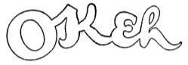 | 175606 | Okeh | Meisselbach, A. F. Manufacturing Company
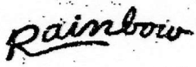 | 117573 | Rainbow | Meisselbach, A. F. & Brother
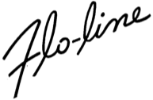 | 522955 | Flo-Line | Meyer, Lou Co
 | 600728 | Kaycon | Miller, William P.
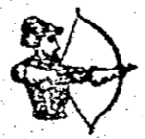 | 57707 | Archer | Milward, H. & Sons Ld
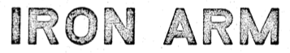 | 38211 | Iron Arm | Milward, Henry & Sons Limited
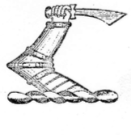 | 38323 | Iron Arm | Milward, Henry & Sons Limited
 | 57216 | Iron Arm | Milward, Henry & Sons Limited
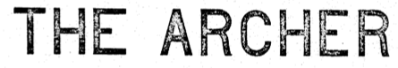 | 58309 | Archer | Milward, Henry & Sons Limited
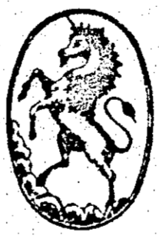 | 58949 | Unicorn | Milward, Henry & Sons Limited
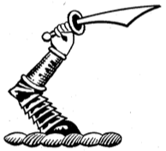 | 221738 | Iron Arm | Milward, Henry & Sons Limited
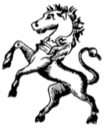 | 224494 | Unicorn | Milward, Henry & Sons Limited
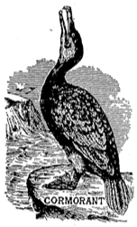 | 240180 | Cormorant | Milward, Henry & Sons Limited
 | 246567 | Flycraft | Milward, Henry & Sons Limited
 | 246568 | Hexacane | Milward, Henry & Sons Limited
 | 433178 | Lucky Louie | Minser, William David
 | 547526 | Modell's | Modell, Henry & Co.
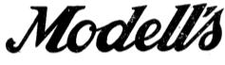 | 276360 | Modell's | Modell's Of New York
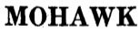 | 663743 | Mohawk | Mohawk Sporting Equipment Co
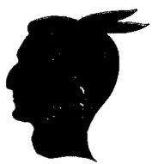 | 664351 | Indian Head | Mohawk Sporting Equipment Co
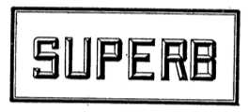 | 194720 | Superb | Montague Rod and Reel Company
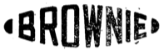 | 196013 | Brownie | Montague Rod and Reel Company
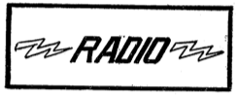 | 202370 | Radio | Montague Rod and Reel Company
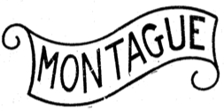 | 223732 | Montague | Montague Rod and Reel Company
 | 360839 | Offshore | Montague Rod and Reel Company
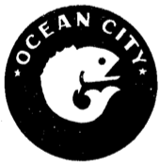 | 639292 | Ocean City | Montague-Ocean City Rod & Reel Co
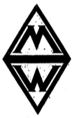 | 106987 | MW | Montgomery Ward & Co., Inc.
 | 677999 | Golden West | Munson Sporting Goods Co. Inc
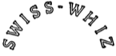 | 549248 | Swiss-Whiz | Myco Inc
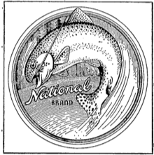 | 370898 | National Brand | National Merchandise Corporation
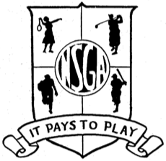 | 339964 | NSGA | National Sporting Goods Association
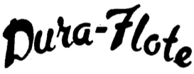 | 615299 | Dura-Flote | Net Machine, Inc
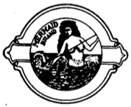 | 86441 | Mermaid | Newton Line Company
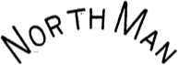 | 440473 | North Man | North, John E.
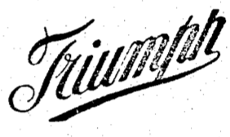 | 76127 | Triumph | Norvell-Shapleigh Hardware Company
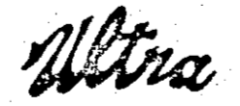 | 76455 | Ultra | Norvell-Shapleigh Hardware Company
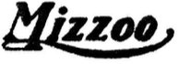 | 77949 | Mizzoo | Norvell-Shapleigh Hardware Company
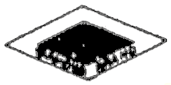 | 81289 | Diamond | Norvell-Shapleigh Hardware Company
 | 441498 | Westpoint | Oakes & Company
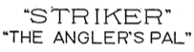 | 216894 | Striker The Angler's Pal | Ocean City Manufacturing Company
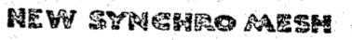 | 316041 | New Synchro Mesh | Ocean City Manufacturing Company
 | 355776 | Zephaloy | Ocean City Manufacturing Company
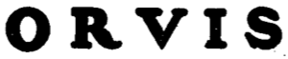 | 580991 | Orvis | Orvis, Chas F. Company, Inc
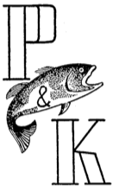 | 428840 | P & K & Fish | Pachner & Koller, Inc
 | 427021 | Man with Pipe | Pacific Outdoor Products, Inc
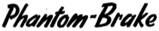 | 427022 | Phantom-Brake | Pacific Outdoor Products, Inc
 | 427023 | For Your Fishing Finesse | Pacific Outdoor Products, Inc
 | 609882 | PICO | Padre Island Co Inc
 | 507650 | Blue Ox | Paul Bunyan Bait Company
 | 609056 | Paul Bunyan | Paul Bunyan Bait Company
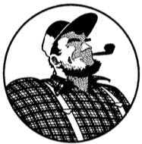 | 609057 | Paul Bunyan in Circle | Paul Bunyan Bait Company
 | 628189 | Monofil | Penn Fishing Tackle Mfg. Co
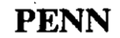 | 674119 | Penn | Penn Fishing Tackle Mfg. Co
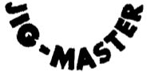 | 678003 | Jig-Master | Penn Fishing Tackle Mfg. Co
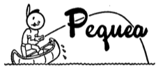 | 611388 | Pequea | Pequea Fishing Tackle Inc
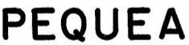 | 665005 | Pequea | Pequea Fishing Tackle, Inc
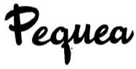 | 549326 | Pequea | Pequea Works, Inc
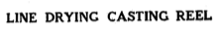 | 145899 | Line Drying Casting Reel | Peters Bait Co
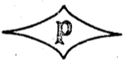 | 65990 | P | Pflueger, E. A. Company
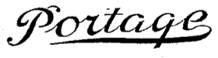 | 87478 | Portage | Pflueger, E. A. Company
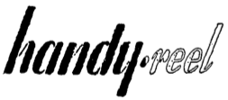 | 580141 | Handy-Reel | Price-Driscoll Corporation
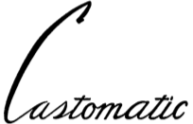 | 509055 | Castomatic | Quaker City Gear Works, Inc
 | 634802 | Pan-American | Raymond's Inc
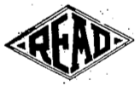 | 121567 | Read | Read, William & Sons, Inc.
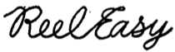 | 624653 | ReelEasy | Reel-Easy Corporation
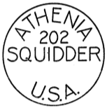 | 520127 | Athenia 202 Squidder | Reimesch, John F.
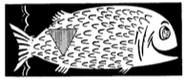 | 393725 | Fish | Richardson Rod & Reel Co
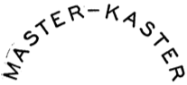 | 349114 | Master-Kaster | Rinehart, Harvey E.
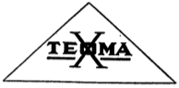 | 433200 | Texoma | Roberts, Sanford & Taylor Co
 | 695253 | Reb-L | Robinson Company
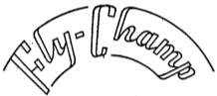 | 440499 | Fly-Champ | Rosner, Ernest B.
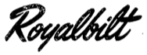 | 501557 | Royalbuilt | Royal Engineering Co
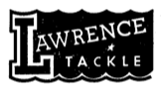 | 610322 | Lawrence Tackle | Rubin, Herbert
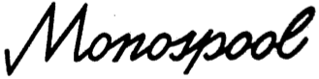 | 635867 | Monospool | Rubin, Herbert
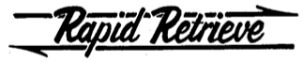 | 677114 | Rapid Retrieve | Rubin, Herbert
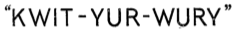 | 218434 | Kwit-Yur-Wury | Ruggles, Charles S.
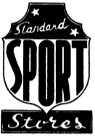 | 428318 | Standard Sport Stores | Runyan, Robert H.
 | 325738 | Aeroplane | Scanlan, Earl M.
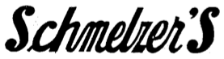 | 114657 | Schmelzer's | Schmelzer Arms Co
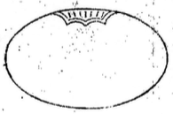 | 116244 | Oval | Schmelzer Arms Co
 | 618999 | Char-Lem | Schrall, Charles L.
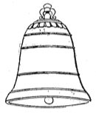 | 96462 | Bell | Schwarz, F.A.O.
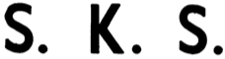 | 442797 | S.K.S. | Scott, Charles W.
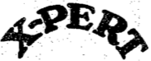 | 290127 | X-Pert | Sears, Roebuck and Co
 | 281923 | Meadow Brook | Sears, Roebuck and Co.
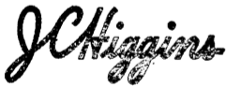 | 588493 | JCHiggins | Sears, Roebuck and Co.
 | 549813 | Seefab | See Fabriks Aktiebolag
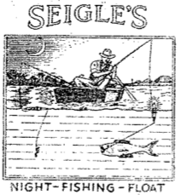 | 313136 | Seigle's | Seigle's Night Fishing Float Company
 | 254370 | Honor Built Honor Sold | Shakespeare Company
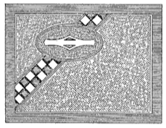 | 258239 | Company Logo | Shakespeare Company
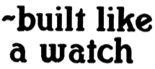 | 259222 | Built Like A Watch | Shakespeare Company
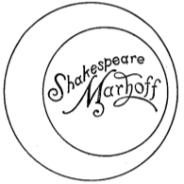 | 282509 | Marhoff | Shakespeare Company
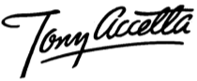 | 359124 | Tony Accetta | Shakespeare Company
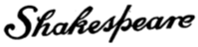 | 359879 | Shakespeare | Shakespeare Company
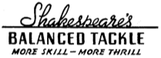 | 365746 | Shakespeare's Balanced Tackle | Shakespeare Company
 | 382338 | Tru-Art | Shakespeare Company
 | 432842 | Wonder-Full | Shakespeare Company
 | 443590 | Wondereel | Shakespeare Company
 | 575729 | Honor Built for over Fifty Years | Shakespeare Company
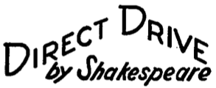 | 580535 | Direct Drive by Shakespeare | Shakespeare Company
 | 582119 | Built Like a Watch | Shakespeare Company
 | 651155 | Wonder Cast | Shakespeare Company
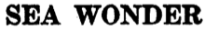 | 678004 | Sea Wonder | Shakespeare Company
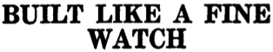 | 690158 | Built Like A Fine Watch | Shakespeare Company
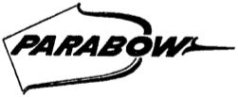 | 695603 | Parabow | Shakespeare Company
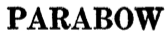 | 700882 | Parabow | Shakespeare Company
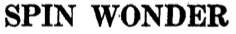 | 700895 | Spin Wonder | Shakespeare Company
 | 438073 | Tops In World | Shapiro Distributing Co
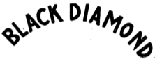 | 176820 | Black Diamond | Shapleigh Hardware Company
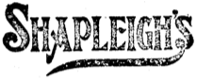 | 284908 | Shapleigh's | Shapleigh Hardware Company
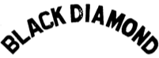 | 504119 | Black Diamond | Shapleigh Hardware Company
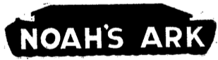 | 263550 | Noah's Ark | Sher, Noah P.
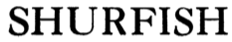 | 356054 | Shurfish | Shurkatch Fishing Tackle Co., Inc.
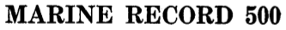 | 648883 | Marine Record 500 | Siegrist-Haerry, Karl
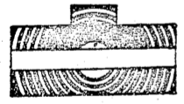 | 133821 | Company Logo | Simmons Hardware Company
 | 144331 | Simmons | Simmons Hardware Company
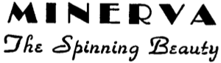 | 615649 | Minerva The Spinning Beauty | Sitbon, Edouard D.
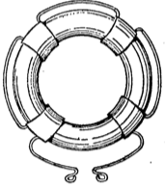 | 566830 | Life Preserver | Societe & Res. Ltd Viellard-Migeon & Co
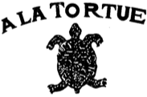 | 527873 | A la Tortue & Turtle | Societe Anonyme in Soie
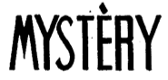 | 577362 | Mystery | Societe Anonyme La Sole
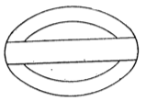 | 89384 | Company Logo | South Bend Bait Co
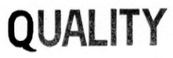 | 151048 | Quality | South Bend Bait Co
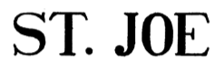 | 179779 | St. Joe | South Bend Bait Co
 | 183114 | Oreno | South Bend Bait Co
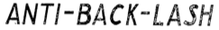 | 270286 | Anti-Back-Lash | South Bend Bait Co
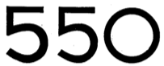 | 271981 | 550 | South Bend Bait Co
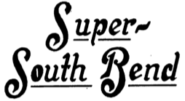 | 277557 | Super-South Bend | South Bend Bait Company
 | 289899 | Best-O-Luck | South Bend Bait Company
 | 329799 | Oren-O-Matic | South Bend Bait Company
 | 341256 | Academy | South Bend Bait Company
 | 344922 | Balanced Reel | South Bend Bait Company
 | 355706 | Obite | South Bend Bait Company
 | 507641 | South Bender | South Bend Bait Company
 | 520150 | South Bend | South Bend Bait Company
 | 521516 | Nip-I-Diddee | South Bend Bait Company
 | 545720 | Deceiver | South Bend Bait Company
 | 551377 | SpinneReel | South Bend Bait Company
 | 555746 | Spin-Cast | South Bend Bait Company
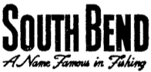 | 558121 | South Bend | South Bend Bait Company
 | 563205 | Smoothcast | South Bend Bait Company
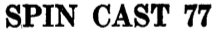 | 646417 | Spin Cast 77 | South Bend Tackle Company, Inc.
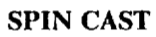 | 648186 | Spin Cast | South Bend Tackle Company, Inc.
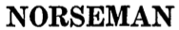 | 677282 | Norseman | South Bend Tackle Company, Inc.
 | 698932 | Contour Control | South Bend Tackle Company, Inc.
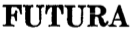 | 698933 | Futura | South Bend Tackle Company, Inc.
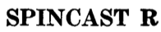 | 699371 | Spincast R | South Bend Tackle Company, Inc.
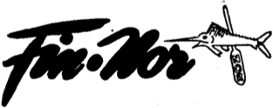 | 633099 | Fin-Nor | Southern Tackle Distributors Inc
 | 602130 | Goldenrod | Southwester Company
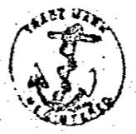 | 14302 | Anchor | Spalding, A. G. & Bros
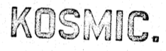 | 17685 | Kosmic | Spalding, A. G. & Bros
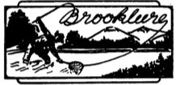 | 418968 | Brooklures | Spiegel Inc
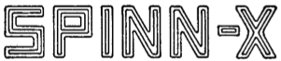 | 594175 | Spinn-X | Spinn-X Co
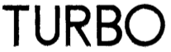 | 626138 | Turbo | Sportex G. m. b. H.
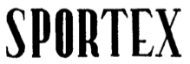 | 626142 | Sportex | Sportex G. m. b. H.
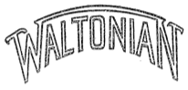 | 237865 | Waltonian | Square Stamping Company
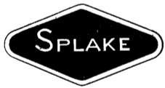 | 648181 | Splake | Stutz, Walter A. Inc
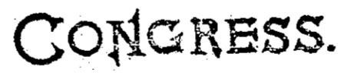 | 57173 | Congress | Supplee Hardware Company
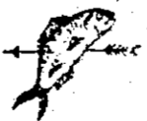 | 57236 | Fish & Arrow | Supplee Hardware Company
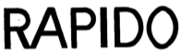 | 609516 | Rapido | Terrier, Felix
 | 615654 | Filvit | Terrier, Felix
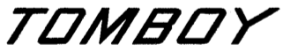 | 597031 | Tomboy | Thommen, Inc
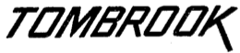 | 597032 | Tombrook | Thommen, Inc
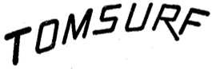 | 665013 | Tomsurf | Thommen, Inc
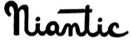 | 500449 | Niantic | Thompson's Sporting Goods
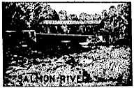 | 504714 | Salmon River | Thompson's Sporting Goods
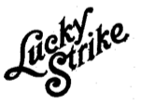 | 136964 | Lucky Strike | Thomson-Diggs Co
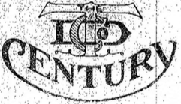 | 151973 | TDC Century | Thomson-Diggs Company
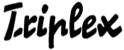 | 600718 | Triplex | Thoner, Wilhelm
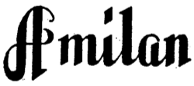 | 589183 | Amilan | Toyo Rayon Co., Ltd
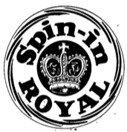 | 612992 | Spin-in Royal | Tradewinds Inc
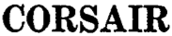 | 644134 | Corsair | Trimline Tackle Co. Inc
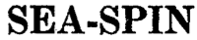 | 645075 | Sea-Spin | Trimline Tackle Co. Inc
 | 645076 | Trim-Spin | Trimline Tackle Co. Inc
 | 654733 | Trimline | Trimline Tackle Co. Inc
 | 667066 | Trim-Sport | Trimline Tackle Co. Inc
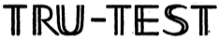 | 345207 | Tru-Test | Tru-Test Brokerage Corporation
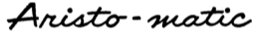 | 612123 | Aristo-matic | True Temper Corporation
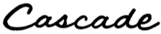 | 612124 | Cascade | True Temper Corporation
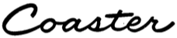 | 612125 | Coaster | True Temper Corporation
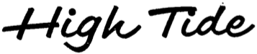 | 612127 | High Tide | True Temper Corporation
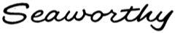 | 612129 | Seaworthy | True Temper Corporation
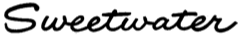 | 613000 | Sweetwater | True Temper Corporation
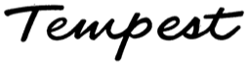 | 613001 | Tempest | True Temper Corporation
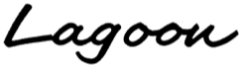 | 615302 | Lagoon | True Temper Corporation
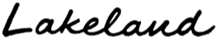 | 625772 | Lakeland | True Temper Corporation
 | 708047 | TT in Box | True Temper Corporation
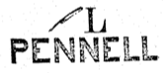 | 57141 | L & Feather Pen - Pennell | Tryon, Edw. K. Company
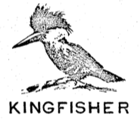 | 61292 | Kingfisher | Tryon, Edw. K. Company
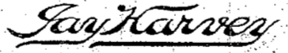 | 166751 | Jay Harvey | Tryon, Edw. K. Company
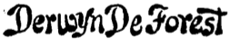 | 182515 | Derwyn De Forest | Tryon, Edw. K. Company
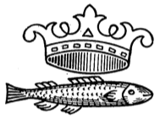 | 190823 | Fish & Crown | Tryon, Edw. K. Company
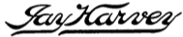 | 417263 | Jay Harvey | Tryon, Edw. K. Company
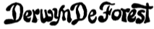 | 417264 | Derwyn De Forest | Tryon, Edw. K. Company
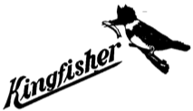 | 418455 | Kingfisher | Tryon, Edw. K. Company
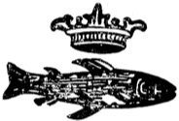 | 507523 | Fish & Crown | Tryon, Edw. K. Company
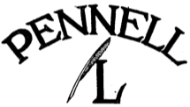 | 511745 | Pennel, L & Pen | Tryon, Edw. K. Company
 | 525575 | Allready | Tryon, Edw. K. Company
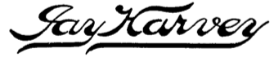 | 611758 | Jay Harvey | Tryon, Edw. K. Company
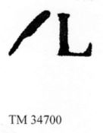 | 34700 | L & Feather Pen | Tryon, Edward K. Jr. & Company
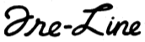 | 527970 | Fre-Line | Uerling, L. J.
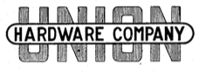 | 205743 | Union | Union Hardware Company
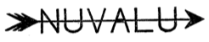 | 199803 | Nuvalu | United States Athletic Company
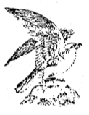 | 15963 | Falcon | United States Net and Twine Company
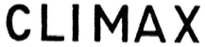 | 24979 | Climax | United States Net and Twine Company
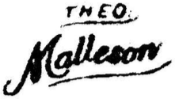 | 26308 | Theo. Malleson | United States Net and Twine Company
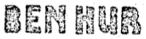 | 317772 | Ben Hur | Van Camp Hardware & Iron Company
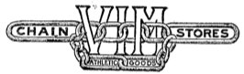 | 194304 | VIM | VIM Chain Stores
 | 635145 | Spinflex | Voedisch Bros. Inc
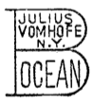 | 237378 | B Ocean | vom Hofe, Julius
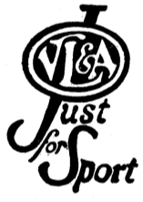 | 255217 | V L & A Just For Sport | Von Lengerke & Antoine
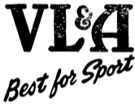 | 525657 | V L & A Best for Sport | Von Lengerke & Antoine
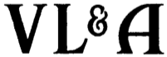 | 643897 | V L & A | Von Lengerke & Antoine
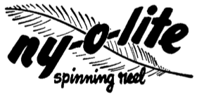 | 588675 | Ny-O-Lite | Waltco Products
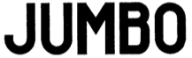 | 261416 | Jumbo | Waters, Thomas J.
 | 408870 | WASCO | Western Auto Supply Company
 | 575184 | Revelation | Western Auto Supply Company
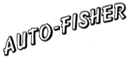 | 528664 | Auto-Fisher | White Bros. & Co
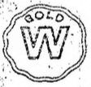 | 121993 | Gold W | Whitney Sporting Goods Company
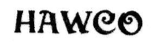 | 81043 | Hawco | Whittemore, Horace A.
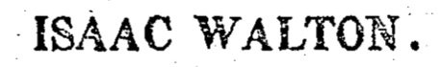 | 67772 | Isaac Walton | Whittemore. Horace A.
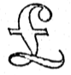 | 72096 | English Pound | Whittemore. Horace A.
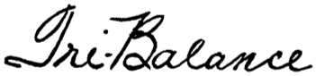 | 637653 | Tri-Balance | Williams, Ted, Inc
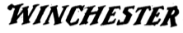 | 159157 | Winchester | Winchester Repeating Arms Co
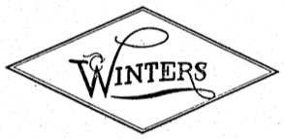 | 74399 | Winters | Winters, Andrew J.
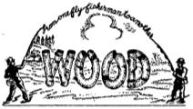 | 379879 | Wood | Wood, C. E. Company
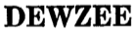 | 702512 | Dewzee | Wood, D. E. Sales Company
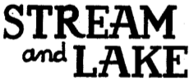 | 617780 | Stream and Lake | Wright & McGill Co
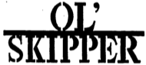 | 421206 | Ol'Skipper | Wynne Precision Company
 | 425555 | Sea Skipper | Wynne Precision Company
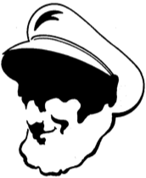 | 425556 | Sea Skipper | Wynne Precision Company
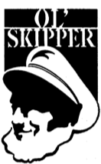 | 425557 | Ol' Skipper | Wynne Precision Company
 | 427253 | Ol' Fisherman | Wynne Precision Company
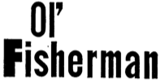 | 432810 | Ol'Fisherman | Wynne Precision Company
 | 430744 | Beaudex | Young, J.W. & Sons
 | 430745 | Pridex | Young, J.W. & Sons
 | 576824 | Ambidex | Young, J.W. & Sons Limited
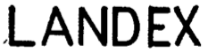 | 576825 | Laudex | Young, J.W. & Sons Limited
 | 669116 | Feathertouch | Zebco Company
 | 669832 | Scottee 66 | Zebco Company
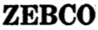 | 689435 | ZEBCO | Zebco Company
 | 527894 | ZEBCO | Zero Hour Bomb Company
 | 545019 | Monti | Zwicker-Graf Mfg. Co, Inc

